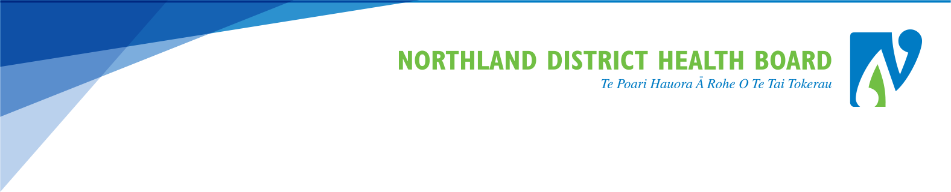

LEARN - Creating your new account (NDHB employees and authenticated partners)

Authenticated partners are: NorthTec, North Haven Hospice, etc

From Staff Central click on either of the links,  Alternatively click on this hyper link  Northland LEARN  Look in Find Courses for Northland DHB | 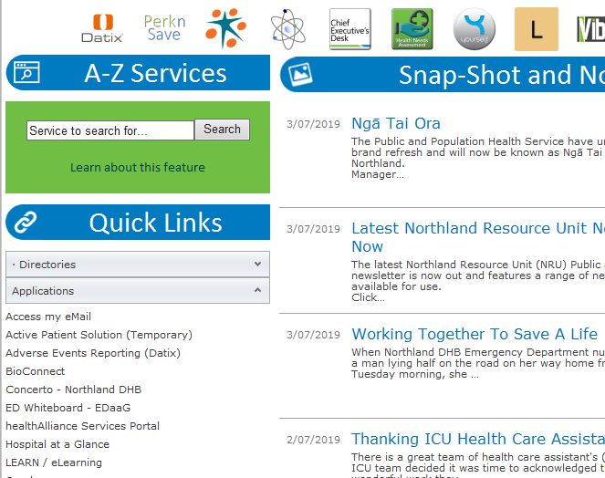
Click on the  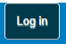  button | 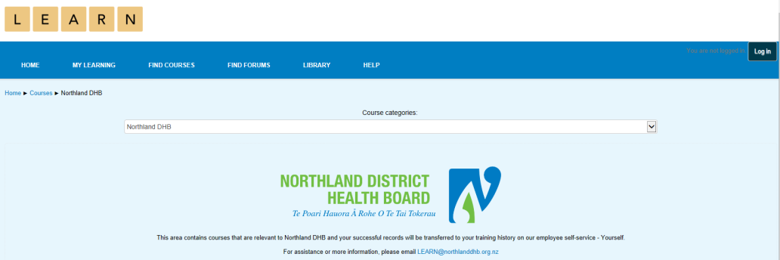
Click on the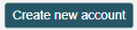  button | 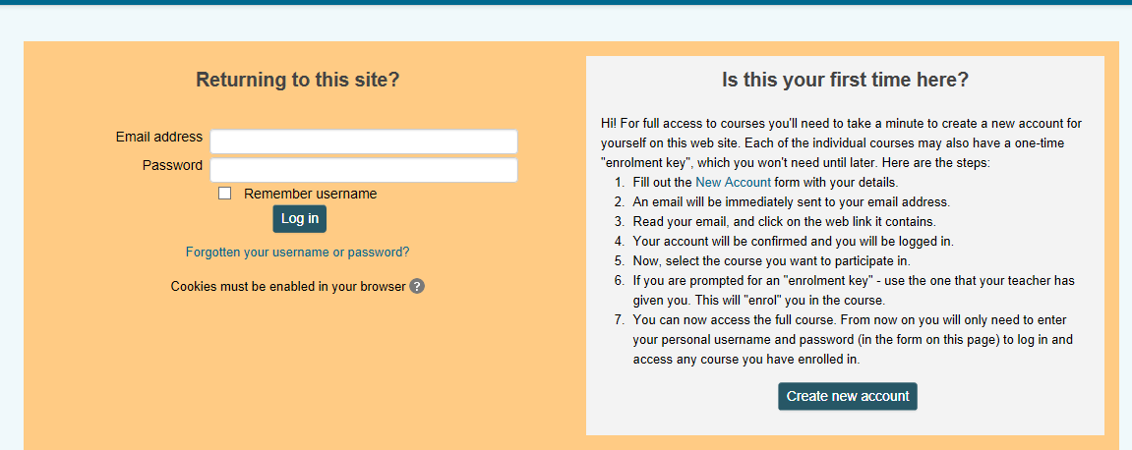
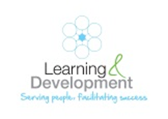
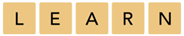

For our organisation users, your work or student email address is now your username  e.g. joe.bloggs@northlanddhb.org.nz is Joe’s email address and username.  Or joeb@northhavenhospice.org.nz  Enter email address (twice) and choose a password  Note: click on unmask to check that your password is correct | 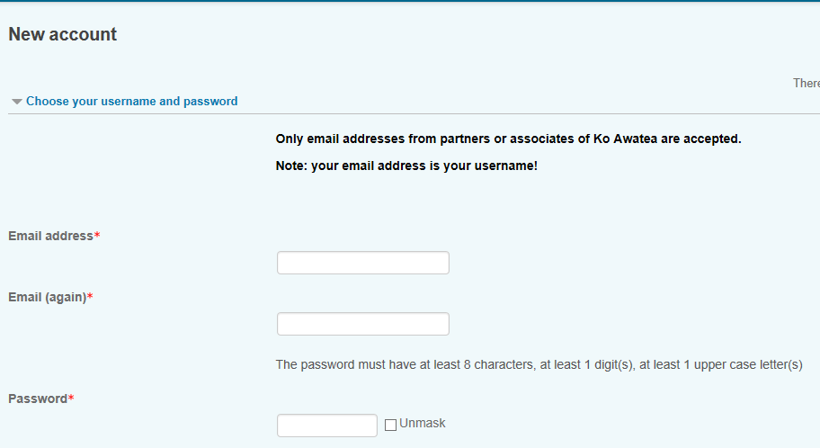
Enter your first name, surname and city/Town  Country is selected for you – default is New Zealand  Choose Northland District Health Board from the pick list as your organisation  Enter your employee number if Northland DHB staff or leave it blank if unknown or unsure. Don’t guess!  All others enter ZZ, i.e non-employees of Northland DHB - PHO, Hospice, NorthTec etc | 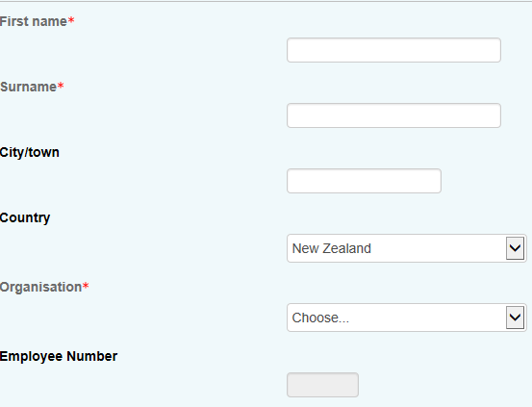  Note: Employee Number is important for Northland DHB employees as this will transfer your training record from LEARN to YourSelf overnight.  You can add employee number later via My Profile.
Choose your primary role from the pick list. | If its not there, Choose Other… and enter your role in the Other role field
Then click on the  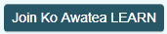  button | 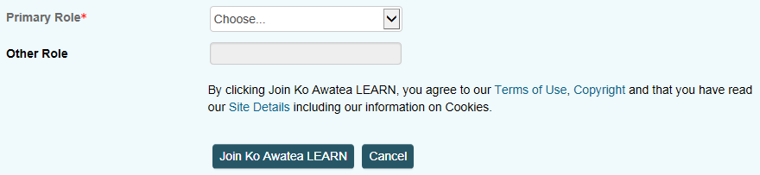
Check your email for the confirmation | Click the confirmation link in your email to confirm the new account.

